Former DUP adviser targets UUP South Belfast nomination
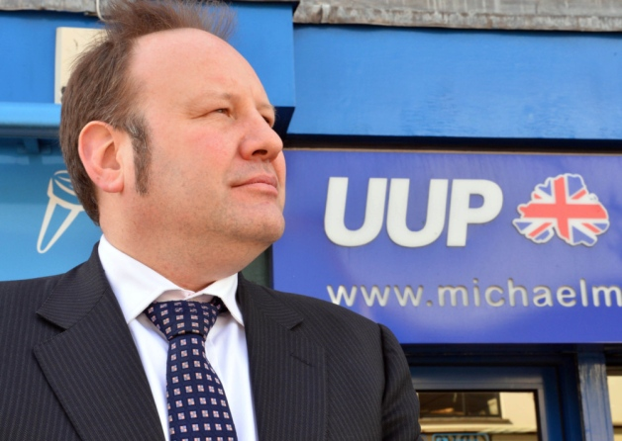
Graham Craig joined the UUP earlier this year
News Letter
2 December 2014
09:00
Print this

A former ministerial adviser to Sammy Wilson has said that he is attempting to secure the UUP’s nomination as its South Belfast general election candidate.
Graham Craig, who joined the party earlier this year and quickly won a seat in May’s council election, said that sitting MLA Michael McGimpsey had indicated to party members that he would not be seeking the nomination in favour of a younger candidate.
The seat was once firmly in the UUP’s control, having been held by the likes of Robert Bradford and Martin Smyth, but has been an SDLP stronghold in recent years and is held by SDLP leader Alasdair McDonnell.
There have been calls for a unionist unity candidate to oust Dr McDonnell.
Mr Craig, an economist who advised Mr Wilson when he was Finance Minister, told the News Letter: “As recently as last week, I had expected the candidate to be Michael McGimpsey and had been working hard preparing to campaign for him in my constituency.
“However, in recent days Michael has spoken to myself and others, making it clear that he thought that the time had come for a younger man or woman to represent the unionist cause in South Belfast – someone who could not only regain the Westminster seat but could hold it for 15 or 20 years; someone in their early 40s not someone in their late 60s like himself.”
Mr Craig said he “admired” Mr McGimpsey as “it is difficult for anyone who has been a politician as long as Michael has to recognise when it is time to pass the torch to the next generation”.
But he said that if a member of the McGimpsey family was chosen for the vacancy it would be “extremely disappointing” as “family dynasties are what we have come to expect from Fianna Fail or the DUP”.

