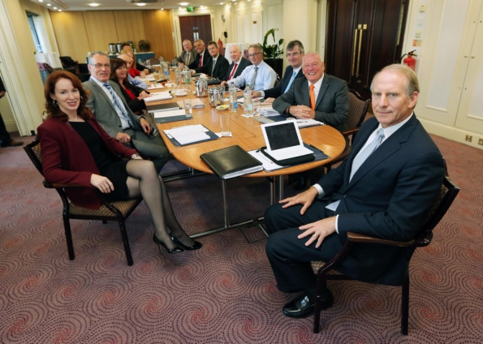
Dr. Richard Haass, Chairman of the Panel of Parties in the NI Executive and Dr. Meghan L. O’Sullivan pictured with representatives from Stormont's five main executive parties.
Europa Hotel, 20 September 2013

