Book review: Northman: John Hewitt, 1907-87. An Irish Writer, His World, and His Times
0

Saturday, October 10, 2015
Review: Thomas McCarthy
I WISH I’d known in November 1982 what I know now, having read this extraordinary biographical study of John Hewitt by W J McCormack (who is more widely known as the Dolmen Press poet, Hugh Maxton).
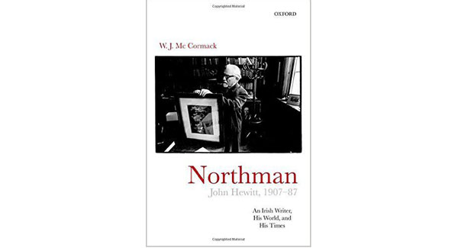
WJ McCormack
Oxford University Press
All those years ago, having listened to my poems at the launch of Younger Irish Poets, Hewitt put his hands on my shoulders and said: “McCarthy, you are too soft-hearted.”
Ulster encourages the direct and uninvited word of censure.
In the pub later that evening I told Hewitt about the young British soldier I’d seen from the train at Portadown, playing with his bomb-disposal Labrador, soldier and dog rolling down a grassy embankment that was peppered with fallen sycamore leaves, the leaves like paprika scattered over soldier and dog.
“Only in Ulster,” said Hewitt sadly, thoughtfully, “only in Ulster.”
Why, in Belfast, did the 1970s become the 1920s all over again, reaching an average of ten murders a week by the middle of the decade? It was a question that Hewitt, an active socialist and lifelong Labour Party supporter, spent a great deal of his waking hours trying to explain.
He belonged to Ulster, first and foremost, to the artisan, linen-weaving Radicals of the North; he loved art and despised grandeur.
His left-wing views and associations certainly cost him a job in Belfast arts administration in 1957, so that he had to make a career in Coventry; a distinguished and fruitful career as director of Coventry’s Herbert Art Gallery where he championed contemporary British artists like Barbara Hepworth. Battles he lost in Belfast he won in the regenerated and rising Labour-controlled Coventry of the 1960s.
In An Irishman in Coventry he wrote: “A full year since, I took this eager city, the tolerance that laced its blatant roar, its famous steeples and its web of girders, as image of the state hope argued for ...”
McCormack paints a full picture of the poet’s life here; Hewitt’s intense attachment to the art of the Soviet satellite states, his socialist Internationalism and his Belfast and industrial North regionalism.
A great deal of the biographical detail here is gleaned from a private diary kept by Hewitt’s wife, Roberta Black, and therein lies a great danger for a literary biographer; a danger that WJ McCormack is aware of: for the keeping of a diary by a spouse is an aggressive act, or, at best, an act of self-preservation.
The real biography of a writer is in the work; the work tells us everything we need to know. Compared to the work itself, all personal evidence is merely hearsay; and diarists, especially, are treacherous companions even in an ordinary life.
Hewitt might have allowed himself to be forgotten were it not for the enthusiasm of the younger, and more famous, John Montague. Montague negotiated a Collected Poems with MacGibbon and Kee in the late ’60s and organised a crucial tour of Northern Ireland that may have re-attached Hewitt to the Belfast that had rejected him.
Blackstaff Press took control of his publishing life, and while Ulster disintegrated, the poet gathered strength. Hewitt’s final Belfast years were, personally, very good, although there was a sense of the fading ‘empire-Commonwealth — “Those happier decades we were dominant/ but now that mastery has flaked away.”
McCormack, with his dense, discursive style acting as a counter-balance to Roberta’s diaries, has produced an important Ulster book one that every Southern politician might usefully read.
http://www.irishexaminer.com/lifestyle/artsfilmtv/books/book-review-northman-john-hewitt-1907-87-an-irish-writer-his-world-and-his-times-358369.html

