Legacy Scandal: ‘Proposals to deal with the past are likely to be sunk by a torrent of opposition,’ says Jeff Dudgeon

News Letter 3 November 2018

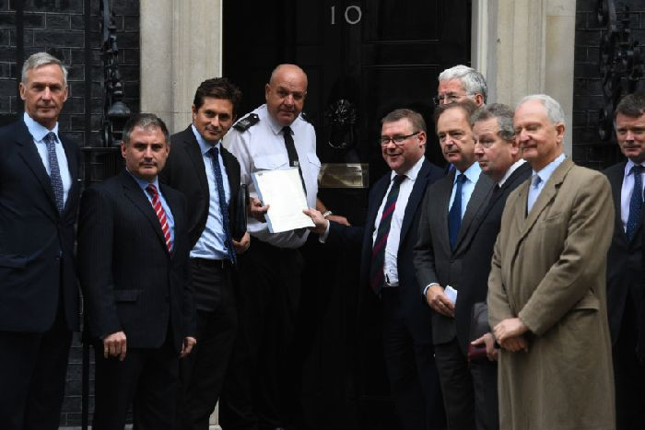
Danny Kinahan, the former Ulster Unionist Party MP and ex guardsman, third from right, joins Tory MPs last month to hand in a petition to 10 Downing Street signed by 104 MPs and peers and senior ex military figures calling for lasting legal protection for Northern Ireland veterans

https://www.newsletter.co.uk/news/opinion/legacy-scandal-proposals-to-deal-with-the-past-are-likely-to-be-sunk-by-a-torrent-of-opposition-says-jeff-dudgeon-1-8692799
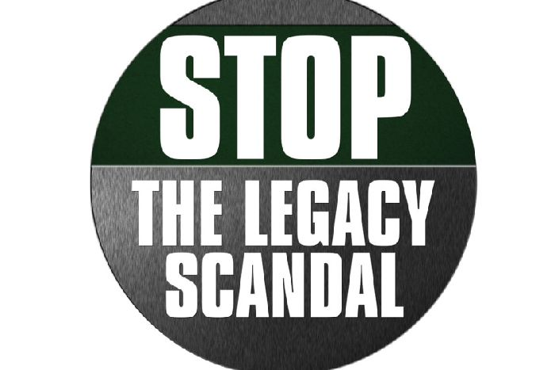

News Letter series for the late summer and autumn of 2018 on how after decades of murder and mayhem in which the IRA was most culpable, the legacy processes have turned against state forces to a grossly disproportionate extent

In a major assessment of where things stand on legacy, JEFFREY DUDGEON writes that the NIO’s whip hand over Downing St on legacy is withering, due to pressure at Westminster over veterans:
The legacy landscape is looking clearer.
We have now reached a watershed in the legacy process with the Northern Ireland Office (NIO) consultation closed.
While the government is in existential crisis over Brexit, it won’t be surprising — considering also the myriad of submissions — that a decision on the legacy bill’s future will not be made for many months, if not years.
And the decision will be ‘No Bill’ or, at least, ‘Not This Bill’.
The body blows landed on the NIO project include, more recently, the statement of condemnation from the Police Federation; the seriously sceptical and well-argued in this newspaper view from former Deputy Chief Constable Alan McQuillan (found in the link at the bottom of this article); and the unique remarks of US General, and former CIA Director, David Petraeus.

Jeff Dudgeon, an Ulster Unionist councillor in Belfast and author or several books. 'Picture by Arthur Allison.
In a reasoned speech, he said “expansive interpretation” at Strasbourg could limit UK forces’ combat ability and that Britain’s military would be “greatly diminished” if human rights laws cannot be balanced against the law of warfare.
Such voices are being heard, often for the first time, and the monopoly of the rights industry on Strasbourg interpretation is only now being challenged and alternatives offered.
The numerous and varied writers in the News Letter’s series Stop the Legacy Scandal (see all essays in the link below) have accentuated the pressure, making it ever plainer that the bill has no supporters outside Sinn Fein, SDLP and the Alliance Party other than government trusties alongside NGOs, certain law firms and the universities.
The current proposals are now very much yesterday.
Many, most notably the victim group South East Fermanagh Foundation (SEFF) and the alternative academics and lawyers from the Malone House Group, have subjected them to hard legal and political analysis for nearly a year.
I edited the conclusions of the Malone House conference in March in the book Legacy: What to do about the Past in Northern Ireland? It was launched at the House of Commons in July and is available on Amazon.
Our view, then and now, is that the proposed bill should be abandoned, not least because of the huge cost and time involved.

A conservative estimate is 15 years and £500 million, something no longer denied by officials. That is three times the NIO’s fake figures of five years and £150 million, and all to no significant value in terms of justice or closure for victims.
There are so many ways to bring about a better, quicker and cheaper result although justice, a very imprecise concept, can never be satisfactorily obtained for the majority of victims, and, in truth, never is.
The NIO’s whip hand over Downing Street on matters legacy is visibly withering, what with the torrent of opposition to the proposals locally, and the huge pressure at Westminster from army veteran MPs over a statute of limitations.
Never before have so many on the mainland taken a stand on a Northern Ireland issue. The Great Britain voices speaking out are indeed unique in Troubles history.
The usual indifference and incomprehension in unhistorically minded Britain has dissipated.
Where the ‘Troops Out Movement’ got no significant purchase on the public mind, this issue has managed to.
Most recently, the unprecedented intervention (ably assisted by Danny Kinahan) from 150 Conservative MPs and peers in a letter to the prime minister against the Historical Investigations Unit (HIU), has to be a death blow to that proposed body.
Mrs May will not easily resist these calls, even if her only concession to date is a Ministry of Defence committee to look into the matter.
It did not help that the NIO deleted any reference to a statute of limitations from their consultation to appease Sinn Fein, along with any proposal for compensation for the seriously injured!
The document feebly states, “the proposal for a pension for severely physically injured victims in Northern Ireland” was not addressed as it was a matter for the (defunct) Northern Ireland Assembly.
A statute of limitations could easily be legislated, perhaps in a very limited way.
It would quite properly be subject in time to legal challenge as is everything here.
The money saved from abandoning the alphabet soup of new institutions — HIU, ICIR, OHA, and IRG, will be enormous and would more than pay generous compensation to those victims who were previously provided with derisory amounts, certainly compared to the most recent Bloody Sunday victims’ pay-outs by the Ministry of Defence.
One has to trace the ancestry of the legacy proposals to understand them.
They emerged in the Stormont House Agreement (SHA), which was in truth an agreement only between the DUP and Sinn Fein.
SHA came a year after the Haass Report of December 2013, and there was little difference where legacy was concerned. But Haass was decisively rejected by Peter Robinson (and indeed the Alliance Party).
In December 2014, he said of SHA it is “as much as and more than we have ever been able to do on these issues in the past. So it is a very significant agreement”.
Yet on legacy, it had all the failings of Haass and no improvements as I know having been a delegate at the talks.
Close inspection suggests it was only a tactical move by Robinson in that he didn’t want the American to achieve a deal which was not part of a SF/DUP arrangement he could broker to advance power-sharing devolution. Perhaps the legacy contents were unimportant to him and were thus agreed with cursory inspection.
This explains how the grotesque HIU came to be accepted by the DUP.
The concept of a parallel police force of the past with powers to track down and arraign retired police officers (but nobody else) for non-criminal ‘misconduct’ grew unchecked out of earlier Police Ombudsman’s proposals.
That was part of the Police Ombudsman mission creep effected by Nuala O’Loan and endorsed by David Ford when minister of Justice.
Context was never considered or taken into account when so many of these cases were re-investigated.
Only with the recent Loughinisland judicial review has there been any fightback against improper overuse of Police Ombudsman powers.
The political parties’ responses to the bill proposals can now be reviewed, in particular that from the DUP who endorse HIU saying, “the DUP considers the best opportunity for justice to come from an investigatory team with full police powers”.
They then quote Article 2 (the right to life) of the European Convention on Human Rights (ECHR) as a reason why: “It is inappropriate for the PSNI to investigate” certain cases, adding, “These realities cannot simply be dismissed”.
Article 2 interpretation, on the duty to undertake effective investigation of deaths and its related Strasbourg jurisprudence, is repeatedly quoted by the DUP and Alliance as making certain things necessary or impossible. That is not so in most cases.
Indeed the UK Supreme Court position remains that Article 2 does not apply in the UK before 2 October 2000.
Our senior courts, under the Human Rights Act 1998, have upheld the McKerr case judgement that there is no investigation obligation to deal with deaths which occurred before that 2000 date.
Whether Foreign Office (FO) and NIO officials act within the parameter of that judgement is a question worth inspecting.
A related aspect is whether Strasbourg has precedence over our Supreme Court. That is not the case but in the gold-plating world of officialdom, and in the lower courts in Belfast, they see things differently.
Later the DUP document states (p. 9), “We have expressed concerns previously at the Police Ombudsman’s involvement in legacy cases, and support an HIU fully taking over the role of the Police Ombudsman (PONI)”.
This amazing remark reveals the party does do not grasp that it is proposed to give HIU greater powers than PONI currently has, powers misused already.
Later the DUP does make the muted remark that “investigations into retired officers should be for criminal behaviour [as] it would be an overhaul of established practice for civilians to be pursued for alleged disciplinary matters as public servants”.
On the Independent Commission for Information Retrieval (ICIR) the DUP writes (p. 12), “We remain to be convinced that the various terrorist organisations will cooperate in a meaningful way to provide detailed and truthful information about why individuals were targeted for murder”.
I am afraid I can provide that information now without an ICIR: They died because they were in the Army, UDR or police and, in the case of loyalist killings, because they were Catholics.
The DUP adds lamely they “did not request this type of mechanism” and says (p. 14) of the proposals that “we will monitor their implementation closely to ensure fairness and impartiality”.
In relation to the so-called Implementation and Reconciliation Group (IRG) the party suggests (p. 14) it “shouldn’t be expensive” although “we remain to be convinced of its value”.
However they agreed to the IRG, despite it being relentlessly proposed in Haass by the SDLP who sought successfully to get ‘patterns and themes’, such as collusion, into the new structures.
As a biographer of Roger Casement, I am dubious of oral history knowing just how different memories and the recall of events can be to earlier documentary evidence.
The difference is often innocent but the Oral History Archive (OHA) is a vehicle for deceit and political obfuscation.
The UUP long favoured the past being examined by historians but not in the stunted form proposed where “patterns and themes” such as collusion will become the major purpose of OHA researchers, despite or perhaps because of the IRG supervising.
The past must not be our future but the bill ensures it will, as it develops ever more novel institutions which themselves will be subject early to judicial reviews and the whole gamut of legal challenge.
The current alternatives are inquests and Strasbourg ‘Article 2 compliance’ cases, not to mention judicial reviews and civil suits, all of which will proceed before, alongside and after these proposed new bodies.
If inquests were included in the HIU, as they could be if government had the courage to take on the dominant academics and lawyers, the bill might be worth considering.
But they aren’t nor will they be.
Instead every inquest can and will be re-opened, particularly, if all the MI5 and security files are handed over by London and new evidence in the form of allegations of never-defined-collusion can be adduced in their hundreds, sufficient to convince yielding judges in Belfast to give leave for judicial review.
Dealing with the past is I suggest one of those problems without a solution – like relationships in a fractured family.
This is primarily because there is a deep seated bitterness about the past between the two communities.
This is unsurprising as the only politics we are permitted revolve around the insoluble ethnic conflict here and the border.
Why do we think we can solve this when in other places subjected to civil war there remain long festering problems?
Furthermore the problems are multi-faceted.
There seems to be a glib assumption among SHA supporters (and most of the media) that the bill with its four new institutions will simplify and rationalise. But of course it will do no such thing as it would be laid on top of — rather than replacing — the existing processes.
Government’s first rule should be ‘Do No Harm’. For that reason alone the bill has to be set aside with the budget instead going to pensions and mental health improvement.
• Jeffrey Dudgeon is an Ulster Unionist Party councillor for Balmoral in South Belfast and the author or editor of recently published books on Montgomery Hyde, Roger Casement and Legacy
• Ben Lowry: Unionism needs talents of people like Dudgeon
• For other essays in the legacy scandal series, click here

