McGimpsey then pulls out
23 February 2018

UUP's Michael McGimpsey has change of heart over return to politics
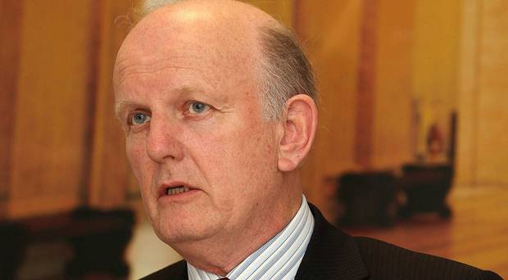1 1 Decision: Michael McGimpsey
By Suzanne Breen
February 23 2018

Former Ulster Unionist Health Minister Michael McGimpsey has changed his mind about making a return to frontline politics.
Mr McGimpsey was seeking to be nominated as his party's council candidate in the Botanic ward of south Belfast. However, he pulled out of the race yesterday.
He told the Belfast Telegraph that he had now decided against coming out of retirement and re-entering politics.
Just three days ago, the 69-year-old, who was Health Minister from 2007-11, said: "My name is in for selection and it will depend on the selection meeting.
"I put myself in for consideration in the Botanic area of south Belfast which I served for 18 years.
"There's a lot to be done in terms of selling a case for the Ulster Unionists in general and I believe the party could do with all the support it can get."
But last night, Mr McGimpsey said he had a change of heart.
"I am confident that I would have been selected by the party and that I would have been elected to the council next year, but I have decided to withdraw," he said.
"There are certain things that need to be said within unionism and, on reflection, I believe I will be able to speak my mind more freely as an ordinary Ulster Unionist member than as an elected representative bound by a corporate discipline."
Mr McGimpsey said the UUP needed a "survival plan" and the DUP needed a "political strategy to promote the Union rather than just relying on voters to get past the next election".
The selection meeting to secure the UUP Botanic nomination will take place tonight. The two leading runners are understood to be Ben Manton, a former south Belfast candidate for the Conservatives, and Richard Kennedy, a treasurer of the UUP's south Belfast association.
Mr McGimpsey announced he was standing down from the Assembly in 2016.
At the time, he said he had considered stepping aside from politics five years earlier but had been convinced to remain for another term to ensure the party did not lose his seat. "I think the time is right for me to go," he said in January 2016.
"I'm 67. If I serve another term I will be 71. I'm fit and healthy and there's a lot I want to do.
"I've thought long and hard about my decision and I feel it is the right thing to do. The party is in a good position. I think my seat is safe and it's time to make way for a younger person - the next generation - to take over. I wanted to go in 2011, but the view of the party was that we would lose the seat."
Before becoming Health Minister, Mr McGimpsey served as Culture Minister at Stormont from 1999 to 2002.
He was first elected to Belfast City Council in 1993 and his brother Chris still represents the UUP there.
The McGimpsey brothers rose to prominence in the mid-1980s when they challenged the Anglo-Irish Agreement by bringing a lawsuit against the Irish government in Dublin.
Belfast Telegraph

https://www.belfasttelegraph.co.uk/news/politics/uups-michael-mcgimpsey-has-change-of-heart-over-return-to-politics-36634413.html

February 20 2018

Belfast Telegraph

Former Stormont health minister McGimpsey eyes return to Belfast Council
By Claire McNeilly

A former health minister in the Stormont Executive is planning to make a dramatic return to politics - as a councillor.
Ulster Unionist veteran Michael McGimpsey has submitted his papers in preparation for the Belfast City Council elections next year.
Mr McGimpsey, who's one of the most recognisable faces in Northern Ireland politics, has thrown his hat into the ring for selection in the Botanic area of south Belfast.
The 69-year-old UUP man, who also served as Culture Minister from 2007 until 2011, said: "My name is in for selection and it will depend on the selection meeting.
"I put myself in for consideration in the Botanic area of south Belfast which I served for 18 years."
He added: "There's a lot to be done in terms of selling a case for the Ulster Unionists in general and I believe the party could do with all the support it can get."
Mr McGimpsey said that his family is fully behind his decision, and he is understood to be a strong contender for the party nomination in Botanic.
A well-placed source told the Belfast Telegraph that there are two other names in the frame for the same patch - Ben Manton, the former South Belfast candidate for the Conservatives, and Richard Kennedy, a treasurer of the UUP's South Belfast association.
Mr McGimpsey's decision to stand down from the Assembly in May 2016 sent shockwaves through political circles.
At the time, he said he had considered stepping away from politics at the 2011 elections but was convinced to remain for another term to ensure the party did not lose his seat.
"I think the time is right for me to go," he said in January 2016.
"I'm 67. If I serve another term I will be 71. I'm fit and healthy and there's a lot I want to do.
"I've thought long and hard about my decision and I feel it is the right thing to do.
"The party is in a good position. I think my seat is safe and it's time to make way for a younger person - the next generation - to take over.
"I wanted to go in 2011, but the view of the party was that we would lose the seat."
Mr McGimpsey, who is originally from Donaghadee, also said he did not want to stand down as an MLA in 2011 because it may have appeared as though he had been chased from his seat after months of personal attacks by his DUP rivals during his final months as health minister.
Mr McGimpsey, who presided over the portfolio with the highest spend in the executive between 2007 and 2011, came under fire from the party as he argued for more money for the Department of Health.
Upon stepping down, Mr McGimpsey, who is also a businessman and involved in property development, said he regarded his time in charge of the health department as one of the highlights of his career.
He was first elected to serve on Belfast City Council in 1993 and his brother Chris still represents the UUP there.
The McGimpsey brothers rose to prominence in the mid-1980s when they challenged the Anglo-Irish Agreement by bringing a lawsuit against the Irish government in the Republic.

