Nationalist homes to be built along Orange Order parade route
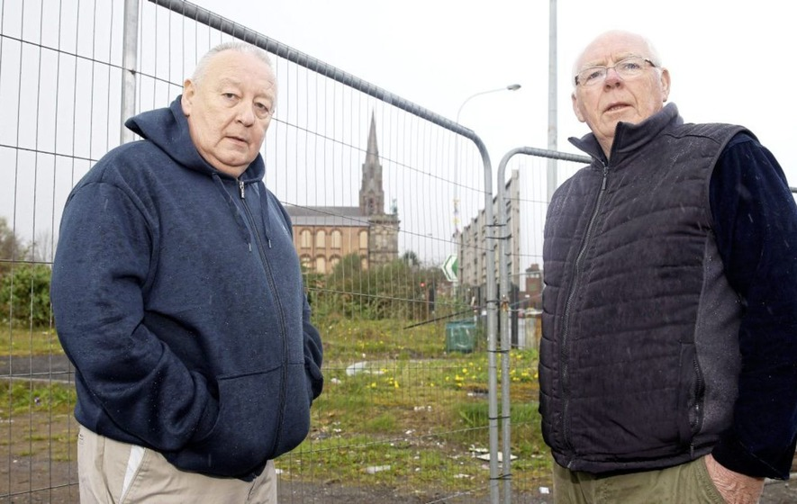
Gerard Brophy and Frank Dempsey at the vacant site on Clifton Street.

Connla Young
Irish News 03 April, 2019 01:00
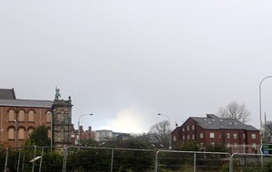
The site at Carrick Hill.
PLANNING approval has been granted to build homes in a flashpoint nationalist area on the Orange Order’s main Belfast parade route.
Belfast City Council planners backed the building project near Carrick Hill in the north of the city.
It proposes four houses and six apartments on a site yards from Clifton Street Orange Hall.
The properties will be the first nationalist homes to be built fronting Clifton Street, which has been a parades flashpoint since 2012.
A similar plan for the site was submitted but withdrawn in 2014. Questions were raised after it emerged that former DUP housing minister Nelson McCausland met housing association representatives at Clifton Street Orange Hall weeks before the plan was withdrawn. He and party colleagues North Belfast MP Nigel Dodds and councillor Brian Kingston are believed to have attended the meeting with officials from the now defunct Oaklee Homes.
At the time the DUP said party representatives held a “meetings with statutory agencies and groups on issues relating to their constituency” and this was a “normal” part of their work. It later emerged that plans to build on the site were scrapped because of a directive by the DUP-run Department for Social Development in documents produced in 2013 that any developments fronting Clifton Street should be non-residential.
A new application to build on the site, at the junction of Stanhope Street and Clifton Street, was submitted last March by Choice Housing Ireland housing association.
Planning documents show that there were no objections.
Planners granted permission on March 28, the same day the site transferred from the Housing Executive to Choice Housing Ireland.
On Tuesday Carrick Hill Residents Association spokesman Frank Dempsey welcomed the development but said he was “angry” that it had taken so long to get the project over the line.
“I am angry that these houses were objected to going back a number of years,” he said.
Gerard Brophy from St Patrick’s and St Joseph’s Housing Association said more can be done to reduce waiting lists.
“It’s a disgrace we had to fight all that time,” he said.
Mr Dempsey has called on other agencies that own land in the area to make it available for social housing.
A spokeswoman for Choice Housing Ireland said: “It is expected that the project will be completed within 12 months.”

