Evidence of OTRs was plain to see
5 Comments
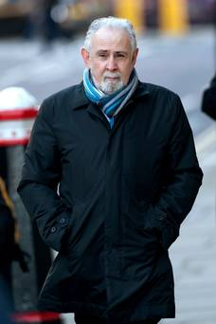
Republican John Downey
By Brian Rowan –
Belfast Telegraph
23 January 2015

What if John Downey had never been arrested? And what if it had never emerged that the Hyde Park bomb suspect had been wrongly given one of the letters of assurance written for republicans still on the run in the period after the Good Friday Agreement?
In those circumstances, would there have been no political probing of this issue - no inquiry by the Northern Ireland Affairs Committee? And, if not, why not?
In investigations, we often hear police officers talk of following the evidence. Did politicians follow the on-the-runs (OTR) evidence?
The answer is no. And that should be one of the conclusions of any report of any inquiry.
Long before the Downey case, the OTRs story was out there. Not in its fine detail, and not in chapters in books, but in many clues.
Indeed, the most detailed and authoritative report was written in this newspaper by the journalist Chris Thornton in June 2007. That was just a few weeks before Downey received his letter.
Thornton's report was stuffed with detail - not speculation, but figures from the Attorney General's office.
This was in the Paisley-McGuinness era. Did no one at Stormont see it or read it?
Go back then, years earlier, through other high-profile cases, including Liam Averill and Eibhlin Glenholmes, and you find other jigsaw pieces that were never used to make a picture.
Glenholmes has been back in Belfast since the summer of 2000. Two years later, at the BBC, I reported on the process leading to her return.
The NIO received a request for information.
It checked with the prosecuting authorities and then confirmed she was no longer wanted.
At the time the NIO said: "Decisions on the prosecution of individuals are a matter for the prosecuting authorities which are independent of government."
My report said "some dozens" of cases had been settled. Clues and more clues.
Then, why have there been no books, or chapters, on the OTRs? The answer is simple.
This was never given the same attention as decommissioning, demilitarisation, the Disappeared, or the devolution of politics and policing.
Brian Rowan is a security journalist

