http://www.belfasttelegraph.co.uk/news/northern-ireland/last-possible-link-to-unsolved-1952-murder-of-judges-daughter-may-have-taken-his-secret-to-the-grave-31503725.html

Last possible link to unsolved 1952 murder of judge's daughter may have taken his secret to the grave
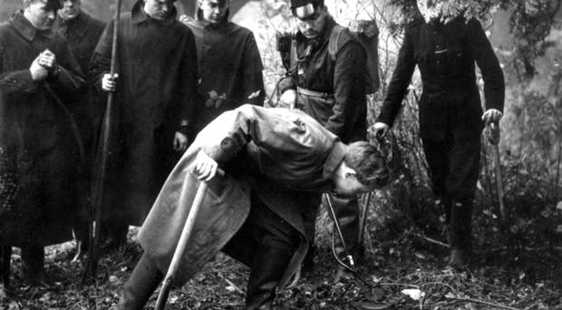4 4 Police comb the murder scene in Whiteabbey for evidence in 1952
By Lesley Houston
September 5 2015
A Belfast historian is confident that the brother of teenager Patricia Curran - whose brutal murder shocked 1950s Ulster - did not wield the knife that killed her.
Belfast councillor Jeffrey Dudgeon last night expressed sadness over the death in South Africa of Father Desmond Curran, who many believe held the last possible key to the unsolved murder that continues to grip Northern Ireland after 60 years.
The brutal murder of the 19-year-old Queen's University student, who was stabbed 37 times in November 1952, has spawned generations of conspiracy theories that her family was behind the killing.
Rumours that the man convicted of the shocking crime, young soldier Iain Hay Gordon, had been scapegoated to save the family's reputation, accelerated following his quiet release just eight years later, in 1960.
He had been found guilty, but insane, with the suspicions shrouding the Currans continuing apace in 2000 when Gordon was cleared of the murder outright, by an appeal judge.
advertisement
The victim's father, Lancelot Curran had served as member for Carrick in the Stormont Parliament from 1945 until 1949 and was the youngest Attorney General in the history of that assembly.
He was senior crown prosecutor for Co Down, Parliamentary Secretary to the Minister of Finance and Chief Whip, and in 1949 was elevated to the High Court bench.
Many believe that Fr Curran takes to his grave the secret of the killing and if his mother was actually guilty - as speculation most pointed toward - no one will ever know but him.
But now drawing on correspondence Mr Dudgeon shared with Fr Curran during his years in South Africa, he reveals Fr Curran assertion of innocence.
In his own hand, following the overturning of Gordon's conviction, Fr Curran wrote: "Now, however, the time has come for me to state categorically that no member of the Curran family was in any way involved in the murder nor in any kind of 'cover-up operation'.
"I am prepared to swear this before any legitimate tribunal. The theories put forward are pure imagination and are not supported by one single shred of evidence."
He said: "I have not answered these accusations before because it did not seem necessary to do so."
Mr Dudgeon said the "colossal" scandal which has clouded the Curran name ever since existed because of their high social and political standing.
"Very few people around wanted to defend an upper class, Protestant unionist and a judge at that and they weren't very good at defending themselves.
"I think I learned quite a bit about Fr Curran over the course of the correspondence.
"He was rather an admirable man who had his own beliefs and principles and, of course, the work he apparently did in South Africa, giving up the material world."
The case has proven to have unending appeal and has been written about in Sean McMahon's book The Bloody North: Infamous Ulster Murder Cases.
Gordon's case has been the subject of documentaries over the years and has also been the subject of a BBC Northern Ireland drama, Scapegoat, which aired in 2009, written by Hole in the Wall Gang members Damon Quinn and Michael McDowell.
On August 28 a social media user shared his memories of Fr Curran.
"Fr Desmond Curran funeral today. Old school Jesuit ministered in Black townships from way back. Had biggest ears ever."
Asked if he believed Father Curran had killed his sister, Mr Dudgeon is confident he didn't stab her.
He does ponder the long debated question: "Was there a conspiracy in the family?
"He wasn't the killer in that he didn't wield the knife, and if you are talking in terms of a court case and trying to get a conviction you wouldn't even get a first step along the way."
Belfast TELEGRAPH

