Peter Geoghegan: Ulster is still problematic
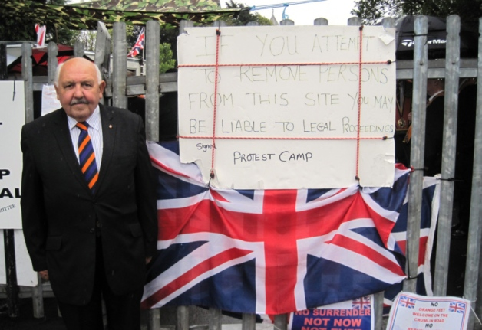
A camp in Belfast set up to protest the restriction of an Orange Order parade. Picture: PA
- by PETER GEOGHEGAN
Updated on the 03 January 2014
Published 02/01/2014
http://www.scotsman.com/news/peter-geoghegan-ulster-is-still-problematic-1-3254218

9 comments

Print this
After the collapse of the Haass talks, power sharing in Northern Ireland is bound to get even more dysfunctional, writes Peter Geoghegan
Have you heard the one about the government minister who, at Christmas, took his cabinet colleague to court in a row over public spending? This might sound like the set-up to a festive gag for political anoraks, but it is exactly what transpired at the High Court in Belfast last week.
Northern Ireland finance minister Simon Hamilton, a Democratic Unionist, initiated the legal action against Sinn Fein agriculture minister Michelle O’Neill. Mr Hamilton won.
From now on, Ms O’Neill will have to seek approval from the rest of the Stormont cabinet over how she distributes European funding.
This, increasingly, is how politics works in Northern Ireland. So it probably should not come as too great a surprise that cross-party peace talks – even those with the imprimatur of the United States – failed to reach a compromise on New Year’s Eve.
But the inability of the five Stormont executive parties to do a deal under the watchful eyes of former US peace envoy Richard Haass was still a shock. In the days – even the hours – leading up to Tuesday’s deadline, Northern Irish political leaders had made positive noises to the media. Dr Haass himself had said he was confident of reaching “meaningful agreement” when he returned to Belfast before Christmas.
Northern Ireland, of course, had been here before, too. From Good Friday, in 1998, through to St Andrews in 2006 and Hillsborough four years ago, every significant agreement in the peace process had been forged in the smithy of late-night brinkmanship. Every time collapse had seemed imminent but, at each juncture, common ground was, eventually, found.
Like most observers, I assumed that another dose of “constructive ambiguity” – a fudge – would reconcile unionists and nationalists on the three big issues of the day: flags, parades and the past. But not this time.
Instead, Dr Haass left Belfast’s Stormont Hotel a failure. Sinn Féin had said they were prepared to recommend the proposals to their executive, but unionists would not sign up to Haass’ seventh and final draft late on Monday night.
Despite Haass’ protestations that he has created a platform upon which compromise can be built, the reality is that little progress his been made.
“Nothing is resolved. There is ambiguity about the process. There is ambiguity about the outcome. We are no closer to understanding the needs of victims, no closer to addressing the past, no closer to an agreement on flags,” a source inside the Haass talks told The Scotsman.
So where does the fault in this failure to reach an agreement lie? In the zero-sum game of Northern Irish politics, the temptation is often to accord blame equally: “a plague on both your houses.” Certainly, recriminations have come quickly on both sides of the sectarian divide: on Tuesday night, just hours after the talks broke up, Ulster Unionist Party negotiator Jeff Dudgeon blamed the cross-community Alliance for the process failing, a far-fetched accusation that gained little traction.
When searching for culprits to finger, Mr Dudgeon would do better to look closer to home. As the final version of the Haass proposals, published on the devolved Stormont government’s website, makes clear, it was unionists who stood firmly in the way of a deal. On a raft of issues, most notably on parading and the past, nationalists, and particularly Sinn Fein, made a number of concessions.
But unionist leaders, more worried about being outflanked from the right – by flag protesters such as Jamie Bryson and Willie Frazier and the hardline Traditional Unionist Voice’s Jim Allister – than doing a deal with Irish nationalism, remained intransigent. After Haass left, Democratic Unionist party first minister Peter Robinson said: “I detect from each of the parties a willingness to work on to complete the task.” A wonder, then, why Mr Robinson did not decide to stick around for the crucial final plenary session of the talks on Monday night.
Ulster unionism has previous when it comes to snatching defeat from the jaws of victory.
You would never know it to listen to Peter Robinson or Ulster Unionist leader Mike Nesbitt, but Northern Ireland’s place in the union has never been more secure. The constitutional question is essentially settled in Northern Ireland – far more settled, at least, than it is here in Scotland.
The Good Friday Agreement enshrined the principle that only the democratic will of the people of Northern Ireland can change its constitutional status. Opinion polls put support for a united Ireland at just one-fifth.
But instead of celebrating their triumph, unionist leaders are embroiled in a myopic culture war that is driving a further wedge between communities in Northern Ireland, in the process making compromise almost impossible.
When Belfast City councilors voted last winter to fly the Union flag from Belfast city hall on designated days, rather than all year round, unionists had an opportunity to claim a history victory. Irish republicans – who just a decade-and-a-half earlier had fought an armed campaign against the British state – were now voting to fly the red, white and blue on the Queen’s birthday!
How did unionism respond? By decrying a democratic decision as an assault on Protestant culture, effectively sanctioning flag-waving loyalist protesters that almost brought Belfast to a standstill.
Meanwhile, a protest camp has been in place since July on north Belfast’s Twaddell Avenue, after an Orange Order parade was prevented from passing through a nearby Catholic area.
Unionists should not take all the blame for the Haass disaster.
Northern Ireland Secretary Theresa Villiers was, as one senior figure put it to me, a “bystander” throughout the talks. Her comments to BBC Radio 4 in the aftermath showed just how out of her depth the Conservative member for Chipping Barnet is in Belfast. “The reality is if you look at issues of identity, some people would argue that it’s been a problem for the last 800 years. In many ways, it’s not surprising that it can’t be fixed in three months.”
Ms Villiers’ party leader, David Cameron, has shown neither aptitude nor inclination for Northern Ireland since he assumed office.
Westminster should have been at the Haass table. These were issues it had a real say in: parading is not devolved, flags are about sovereignty, and the British state was hardly a silent partner in the murky world of “the past”. But instead the British government watched Haass from the sidelines.
Reports of the Good Friday Agreement’s demise are greatly exaggerated. But the default setting at Stormont is conflict, not compromise. “We are in a power-sharing government but we are not sharing power. We are firmly embedded in our own fiefdoms without any sense of responsible, just government,” says John McCallister, deputy leader of the new liberal unionist party NI21 and a former member of the Ulster Unionist Party.
With European and local elections this summer, a Westminster vote next year and devolved elections due in 2016, the political temperature in Northern Ireland is only getting to get hotter. Which is good news for Belfast High Court lawyers, but not for the many people in Northern Ireland who are fed up with “extraordinary” politics.

