OH NO BO

New Tory Veteran Support Group could beat Boris Johnson’s majority if he breaks Northern Ireland promise
Matt Dathan, Deputy Political Editor (Sun)
5 Feb 2020, 21:57
TORY MPs created a new Veterans Support Group to show Boris Johnson they have enough to defeat him if he breaks his promise for a new law to protect Northern Ireland vets.
They fear the Government’s deal to restore power-sharing in Northern Ireland risks opening up new Troubles and probes into thousands of veterans despite the Tory election pledge not to.
It spurred them to form a parliamentary group and after holding their first meeting more than 40 had signed up.
That gives them enough to defeat the Government’s 80-seat majority in the Commons if necessary.
The Veterans Support Group - headed by former Tory leader Sir Iain Duncan Smith - is: “We will defend those who defended us”.
Deputy chairman Mark Francois said they formed the group to “make sure that if and when legislation appears in the Commons the interests of our veterans are properly protected”.
Other senior Tories to join were Owen Paterson, Bob Stewart, Adam Holloway, Richard Drax and Laurence Robertson.
And the PM’s parliamentary aide Alex Burghart was invited to their first meeting last night to show No10 they mean business.
MPs insisted the group was “non-confrontational” and they “want to work with the Government to secure a positive outcome”.

The newly created Veterans Support Group (photo):
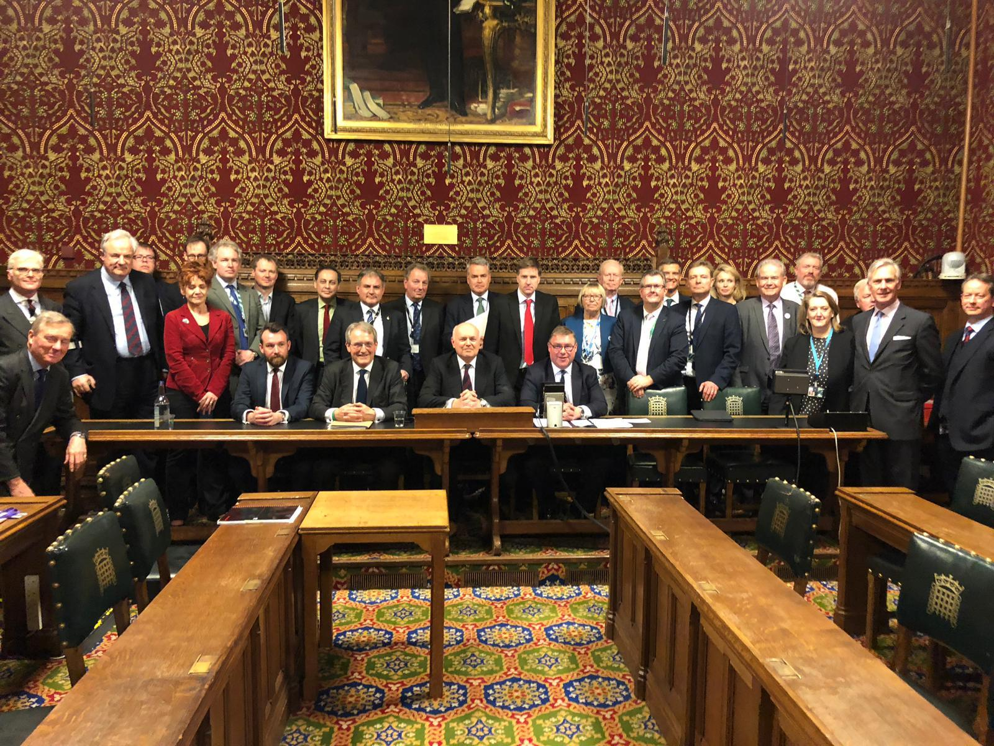
https://www.thesun.co.uk/news/10902404/new-tory-veteran-support-group-boris-johnsons-majority/

