2015 Westminster General Election - Seats changing hands and MPs who lost their seats

111 seats changed hands compared to the result in 2010 plus three by-election gains reverted to the original winner.

The Conservatives lost 11 seats (10 to Labour and one to UKIP in Clacton) and gained 35 (27 from the Liberal Democrats and eight from Labour) making a net gain of 24 seats.

The 10 Conservative seats lost to Labour were Brentford and Isleworth, Chester, Dewsbury, Ealing Central and Acton, Enfield North, Hove, Ilford North, Lancaster and Fleetwood, Wirral West, and Wolverhampton South West.

Some of the MPs - Brentford & Isleworth (Mary Macleod), Chester (Stephen Mosley), Clacton, Dewsbury (Simon Reevel), Ealing Central and Acton (Angie Bray), Enfield North (Nick de Bois), Hove, Ilford North (Lee Scott), Lancaster & Fleetwood (Eric Ollerenshaw), Wirral West (Esther McVey), and Wolverhampton South West (Paul Uppal).

Labour lost 48 seats (40 to the SNP and 8 to the Conservatives) and gained 22 (12 from the Liberal Democrats and 10 from the Conservatives) making a net loss of 26 seats. The eight seats lost by Labour to the Conservatives were Bolton West, Derby North, Gower, Morley and Outwood (Ed Balls), Plymouth Moorview, Southampton Itchen, Telford and Vale of Clywd.

The Liberal Democrats lost 49 seats (27 to the Conservatives, 12 to Labour, and 10 to the SNP) leaving them with eight.

The SNP gained 50 seats (40 from Labour and 10 from the Liberal Democrats) and lost none giving them 56 out of a maximum 59. The three Scottish seats that eluded the SNP were Dumfriesshire, Clydesdale and Tweeddale (Conservative), Edinburgh South (Labour), and Orkney and Shetland (Liberal Democrat).

The Alliance Party lost its only seat (East Belfast) to the DUP.
The DUP lost one seat (South Antrim) to the UUP leaving them with eight.
Sinn Fein lost one seat (Fermanagh and South Tyrone) to the UUP leaving them with four.

Three seats won at by-elections by Labour, UKIP and Respect, respectively, returned to the party that won in 2010: Conservative (Corby, Rochester and Strood) and Labour (Bradford West).

http://www.bbc.co.uk/news/election-2015-32601278

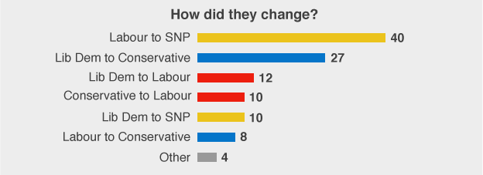

Conservative: 331 seats
Labour: 232 seats
Scottish National Party (SNP): 56 seats
Liberal Democrat (LD): 8 seats
Democratic Unionist Party (DUP): 8 seats
Others (OTH): 15 seats
Despite the seismic consequences of the general election, just 17% of constituencies switched allegiances from one party to another. Nearly half of these 111 seats were in Scotland, as the SNP went from being represented by six MPs to 56. The rest were concentrated in south-west England, where the Conservatives won over many of the Lib Dems' former strongholds, and northern England, where Labour made some gains. Just one seat changed hands in the East Midlands: Derby North.

